TITLE OF PAPER

Author A(First name Last name)1*, Author B², Author C³

¹ Affiant of Author A.
² Affiant of Author B.
³ Affiant of Author C.

ABSTRACT
Over the past most multi-factor stock selection models used score approach, and subjectively set the score weight for each factor. ……………………………

Keywords: stock market, stock selection. 3-5 keywords
1. Introduction
Investors have various preferences and by nature have different requirements for portfolio performance. ……..
The citation format follows APA format

Equation:
Maximize (1)
2. Literature Review
2.1 Multi-factor stock selection model
Several studies in recent years have shown that a combination of effects can be used to construct a stock selection model with a higher rate of return (Piotroski, 2000; Hart et al., 2003; Mohanram, 2005; Roko and Gilli, 2008). Hart et al. (2003) ……
2.2 Design of Experiments
Design of experiments (DOE), a branch of mathematical statistics and scientific research methodology, ….
Equation:
i=1, 2,…., q (4)
(5)

Table 1. Detail parameters in the back testing
Term | Content
Transaction cost | Buy stocks: 0.1425% processing fee  Sell stocks: 0.1425% processing fee and 0.3% transaction tax.
Transaction cycle | Trade on every first trading day of a month.
Back testing period | From early January 1997 to the end of December 2009, for a total of 13 years of stock market data.
Stock sample pool | All listed and OTC stocks in Taiwan, including delisted stocks.
Type of strategy | Buy long.
Trading rule | The buying rule was to buy the stocks with the top 10% of total weighted score to form the stock portfolio. The selling rule was to sell stocks which don’t satisfy the buying rule.

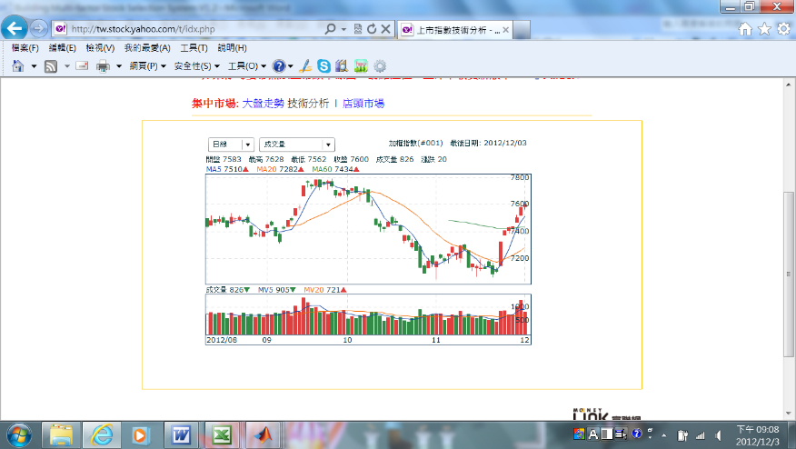
PBR weight
RG weight
R weight
ROE weight
MV weight
beta weight
Return
Total Risk
Sys. Risk
Rel. Winning
Abs. winning
Average MV
Trading strategy simulation mechanism (Back-testing)

experimental strategies (stock selection concept weights)
simulation outputs
(performance indicators)
Figure 1. The simulation mechanism of the system.

CONFLICT OF INTEREST
The authors declare that we have no conflict of interest.

References
ISMDS 2023 follows APA format, please refer to
http://www.apastyle.org/
https://web.archive.org/web/20070713012943/http://library.uww.edu/GUIDES/APACITE.htm

* Corresponding author: E-Mail address This work was funded by XXXXXXXXX, under Grant No. XXX

